**A Deeper Understanding of JavaScript Objects**





var houseKeeper1 = {

yearsOfExperience : 12,

name: "Jane",

cleaningRepoertoire: ["bathroom", "lobby", "bedroom"]

}

houseKeeper1;

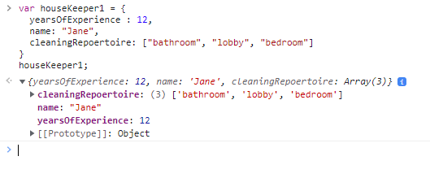

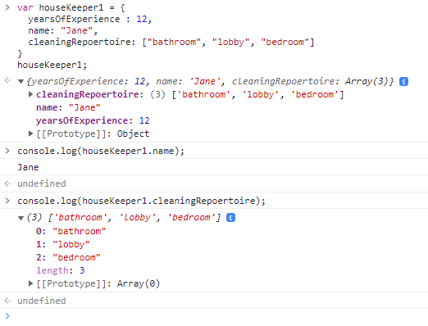







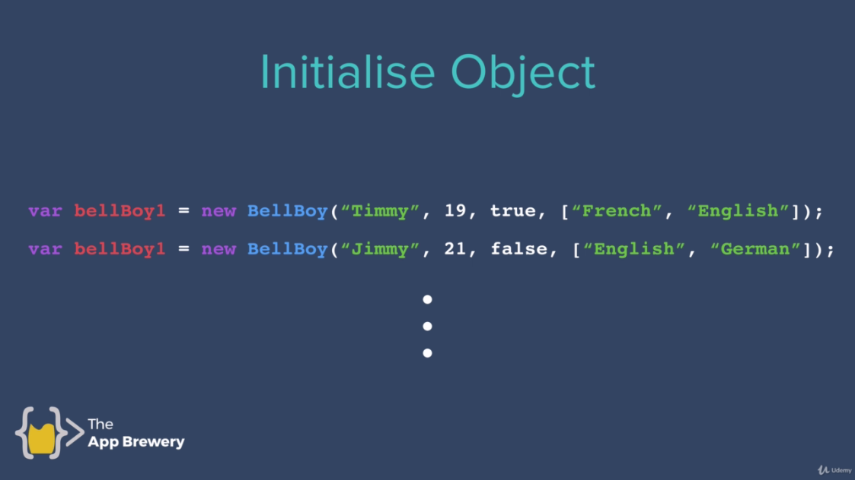

//Initialize Variables

var houseKeeper1 = {

yearsOfExperience : 12,

name: "Jane",

cleaningRepoertoire: ["bathroom", "lobby", "bedroom"]

}

//Create Function

function HouseKeeper(yearsOfExperience, name, cleaningRepertoire){

this.yearsOfExperience = yearsOfExperience;

this.name = name;

this.cleaningRepertoire = cleaningRepertoire;

}

//Cfreate objects

var houseKeeper1 = new houseKeeper1(20, "Tom", ["lobby", "bedroom"]);